Combination of Quaries- Dataset2
Quary-1
select * from student_attendance
where attendance_percentage >= 85 and assignments_completed >= 8;
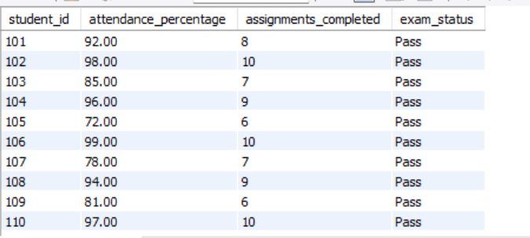
Quary-2
select * from student_attendance
where attendance_percentage < 75 or exam_status = 'fail'
order by attendance_percentage asc;
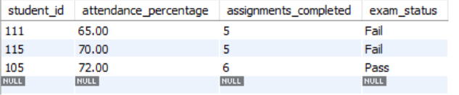
Quary-3
select * from student_attendance
where attendance_percentage between 80 and 95;
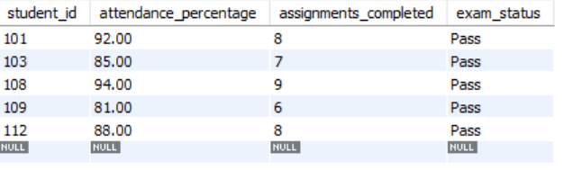

Quary-4
select * from student_attendance
where exam_status in ('pass', 'fail');
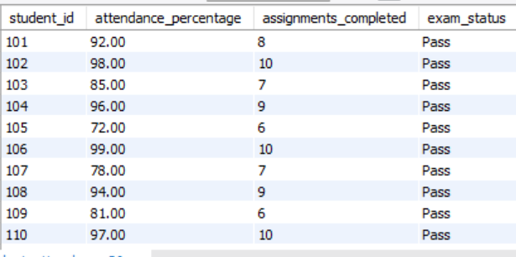
Quary-5
select
count(*) as total_students,
avg(attendance_percentage) as avg_attendance,
max(attendance_percentage) as highest_attendance,
min(attendance_percentage) as lowest_attendance,
sum(assignments_completed) as total_assignments
from student_attendance;
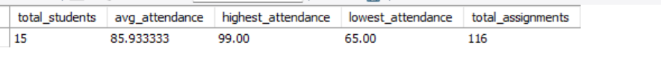
Quary-6
select exam_status, count(*) as student_count, avg(attendance_percentage) as avg_attendance from student_attendance
group by exam_status
having count(*) >= 2;
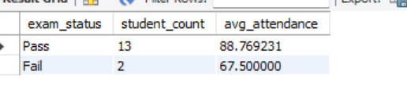
Quary-7
Select student_id, attendance_percentage, assignments_completed,
case
when attendance_percentage >= 90
and assignments_completed >= 8
then 'excellent'
when attendance_percentage >= 75
then 'good'
else 'needs improvement'
end as attendance_performance
from student_attendance;
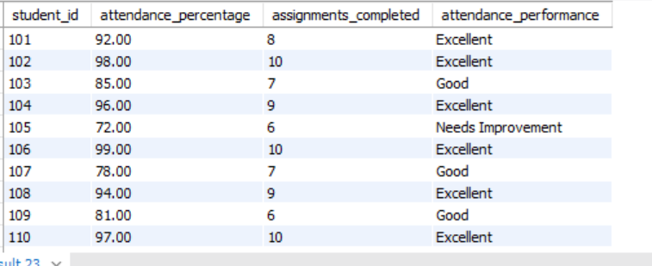

Quary-8
select student_id, attendance_percentage from student_attendance
where attendance_percentage > (
select avg(attendance_percentage)
from student_attendance
);
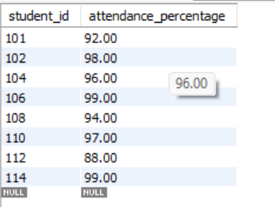
Quary-9
select student_id, attendance_percentage from student_attendance
where attendance_percentage = (
select max(attendance_percentage)
from student_attendance
);
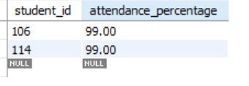
Quary-10
select student_id, assignments_completed from student_attendance
where assignments_completed > (
select avg(assignments_completed)
from student_attendance
);
